The Art of Persuasion - (why this is an important skill to develop)
- The aim of the writer of a piece of persuasive writing is to influence your thinking.
- Do you want to be told what to think?
- Isn’t it better to make up your own mind? This means that you will have to decide for yourself if you agree with the writer’s arguments.
- Is the writer giving you proof you can rely on?

There are different ways to persuade someone:
The first approach relies on Logic: this means that you develop a rational argument using facts.
The second approach relies on Emotion: this means that the writer tries to arouse your feelings by appealing to your emotions (guilt/anger/frustration etc.)

Appeal to Emotion
People don't always think about issues logically. They often make decisions based on their emotions. Writers can take advantage of this habit by using the following techniques:
- The Personal Connection
When writers address you as an individual: "If you have to choose..." This makes it seem as if the writer is talking with you personally, almost as a friend.
- Dialogue With the Reader
Using rhetorical questions allows the writer to set up a dialogue with you. A good reader can phrase a rhetorical question so that most readers will automatically think of the answer the writer wants.
- Loaded Words
Using words that trigger an emotional response. Example: When a writer describes their "cute, blond, brown-eyed daughter," when asked if you had to choose between saving a dog or the daughter, they create a picture of a person you can care about. Without the loaded words, the sentence doesn't have the same impact. Example: "If you had to choose between saving a dog or a human, whose life would you choose?"

Please watch the following Persuasive Speech:


https://www.youtube.com/watch?v=t7911kgJJZc
Direct Link:

https://www.youtube.com/watch?v=t7911kgJJZc
(this link opens in a new window/tab)
(this link opens in a new window/tab)

Conclusion

You have now reached the end of the lesson content for Unit 5.

Next Steps
When you have completed the assignment, submit it for feedback. After you have received feedback, you will be able to complete the Unit 5 Assessment if you are not satisfied with your mark from your assignment. In the meantime, feel free to continue with Unit 6.

Persuasive Techniques in Advertising
Supporting file: 02_SUPPORTING_FILES_BY_UNIT/06 - Unit 5 Informative and Persuasive Texts/Persuasive Techniques in Advertising-c520360420.pdf
Original package path: сontent/i2ccdd67d-8a93-4f97-8d70-aa89b9ce4e86/4.5 Persuasive Marketing Techniques.pdf

How to Read Consumer Information
The main thing to keep in mind when reading consumer information is that someone may be trying to sell you something. Don't let yourself be talked into buying something you don't want or need.
Be clear about your own purpose when you read or view consumer information. If you do want to buy something and are gathering information, be skeptical. Ask yourself: How dependable is this information? Might this writer have a bias? For example, fashion magazines are full of advertisements for beauty products. Do you think articles in these magazines are likely to be critical of their advertisers products?

Analyzing an Advertisement
Every element of an advertisement - the art, the copy, and the layout - is carefully chosen to help sell a product. Here are just a few of the persuasive techniques advertisers use.
- associating a product with an appealing lifestyle and attractive people
- playing on emotions like vanity, the need to belong, or concern for the environment
- band wagoning (Everybody's doing it; you should too!)
- celebrity endorsements
- recommendations from experts
- humour
Being aware of the techniques that advertisers use will help you to be a more critical consumer.

When analyzing the message of an advertisement, you should examine the following elements.

1. Advertising Language
Words have literal meanings but they also appeal to our emotions and connect with our previous experiences. Advertisers choose words with positive associations to appeal to their target audiences.

2. Target Audience and Art
The art chosen for an advertisement usually reflects the age, gender, interests, social class, income, and values of the target audience.

3. Copy
Copy for advertisements is generally written to create an image for a product, not to give information about it.
Consider the following advertisement:

Can you identify:
- words with positive associations?
- target audience?
- information about the product(s)?
- parts of the advertisement that create an image of the product?
(this link opens in a new window/tab)

Why Did I Buy That?
When you go shopping, why do you buy the products that you do?
What makes you choose one brand over another?
Companies spend millions of dollars on advertising campaigns every year to try to convince you to buy their brand.
Why do many companies use logos?


Advertising Claims:
Advertising claims: advertisers of parity products (products in which the brands available are nearly identical, for example: gasoline, soft drinks, candy, soap, etc) use empty claims to create an impression of superiority for their products.
- Unfinished claim: this is when the ad claims the product is better, or has more of something, but does not finish the comparison ex: “ _____ detergent cleans better”
- So-what claim: states an obvious fact as though it was unusual ex: “ ____ bleach kills germs instantly”
- So-called science claim: the public thinks they’re getting reliable scientific information ex: “ ____ sunscreen has been clinically proven to protect your skin from 80% of the harmful rays of the sun.
- So-called survey claim: the public thinks they’re getting reliable statistical information ex: “three out of five doctors surveyed recommend the ____ program for weight loss.”
- We’re different and unique claim: what makes it different? Does the difference make the product any better? Ex: “There’s no other game like _____”
- Compliment the consumer claim: this kind of claim aims to make the consumer feel good by using some form of flattery, ex: “You’re special. You deserve the best! Buy _____ golf balls.”

Weasel Words
Weasel words are words that lack exactness, as a result, they enable advertisers to "weasel" out of a responsibility for proving that the claim is true.
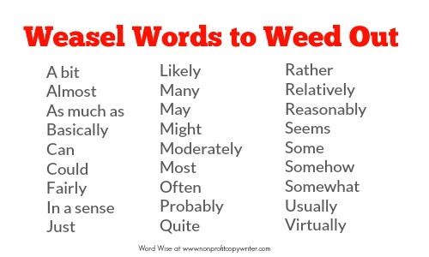
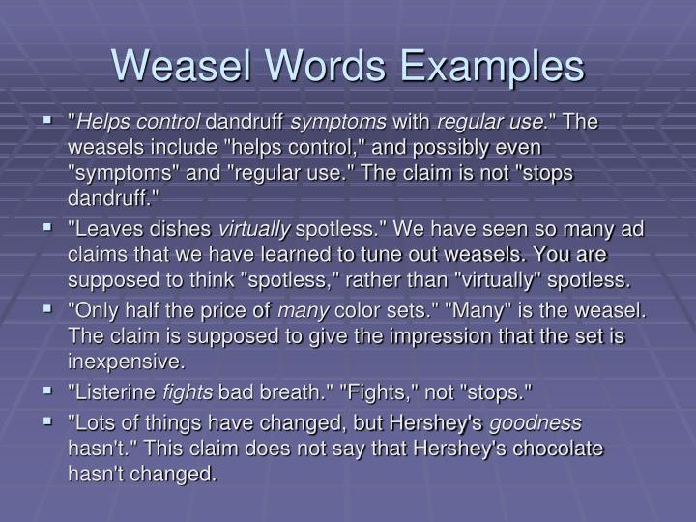

The Rational Argument
It isn't wrong or unfair to appeal to the reader's emotions when building an argument. In fact, it would be foolish for a writer to ignore such a powerful technique. But an appeal to emotion doesn't prove anything. A reader might respond, "I want to agree, but I need some solid evidence before I can accept your point of view." That's why most opinion pieces include rational arguments.
Rational arguments include two key components:
- Providing Reasons - To be persuasive, a writer must support his or her opinion with strong reasons. Strong arguments are based on facts.
Opinion: Animals should be used in research.
Reason: Research offers the only hope for a cure for cystic fibrosis. (this reason should have evidence to support the claim using facts)
- Counterattack - State an opposing argument and then show its weakness.
Opposing argument: "There are advocates for animals who only seek to cut down on 'unnecessary research.'"
Counterattack: "They don't specify how to decide what is unnecessary...."

Read the following opinion piece on the next page:
Do We Need to Use Animals in Research? by Jane McCabe
(this link opens in a new window/tab)

Use of Animals in Research?
Supporting file: 02_SUPPORTING_FILES_BY_UNIT/06 - Unit 5 Informative and Persuasive Texts/Use of Animals in Research-463b89966d.pdf
Original package path: сontent/i71ef4dcd-bf35-460a-b7bd-8fac5e6f37df/Do we need to use animals in research Opinion Piece.pdf

Unsound Arguments
These are arguments that you want to avoid when you are trying to express your opinion/argue a particular perspective:

Generalization:
Arguing that all members of a group are the same. Ex: all teenagers are bad drivers

Confusing Fact and Opinion:
Stating an opinion as through it were a fact. Ex: you can't do research for cancer without using animals.

Name-Calling:
Criticizing the person or group voicing the argument instead of addressing the argument itself. Ex: I disagree with those bleeding-heart liberals who feel sorry for everyone.

Loaded Words:
Choosing words that trigger an emotional response. Ex: How could anyone kill those cute baby seals with their wide-eyed look of innocence? Seal fishing must be banned.

Facts and Opinions
When you read an opinion piece, you want to be able to tell the strong arguments from the weak. Since a strong argument is built upon facts, you need to know what a fact is and how it differs from an opinion. And when you come to write your own arguments, you'll need to be able to support your personal opinions with facts that convince your readers.
A fact is a statement that can be proved to be true . Here's an example: "The earth orbits the sun." If a statement is really a fact, you can't disagree with it. But you can disagree with which facts the writer chooses and which ones they ignore.
An opinion, on the other hand, is a statement that expresses a belief or point of view that cannot be proved one way or the other. "The earth is the most beautiful planet in the solar system." Although many people might agree with this statement, there are many who would not. Some might say, "Saturn is the most beautiful planet because of its rings." Others might say, "All the planets are equally beautiful, but in different ways." An opinion is always open to debate.
A writer can support an opinion with facts, or with other opinions. Facts help to strengthen an argument. Which of the arguments below do you find more convincing?
- Suspect X should be charged with a theft (opinion) because he was riding the stolen bike. (supporting fact)
- Suspect X should be charged with a theft (opinion) because he looks suspicious. (another opinion)

How to Tell an Opinion From a Fact
If you think that a statement is a fact but you're not sure, ask yourself these questions.
- Is there a way of checking the statement to see if it's true?
- Could this statement be confirmed by looking at reference material?
- Could I prove this statement by measuring or counting something?
- Would most people agree with this statement?
If you answer yes, you are probably looking at a fact. If you answer no, you are probably looking at an opinion.
Read the following excerpt:
How has research using animals helped those with CF? (1) Three times a day my daughter uses enzymes from the pancreas of pigs to digest her food. She takes antibiotics tested on rats before they are tried on humans. (2) As an adult, she will probably develop diabetes and need insulin-a drug developed by research on dogs and rabbits. If she ever needs a heart-lung transplant, one might be possible because of the cows that surgeons practice on. There is no animal model to help CF research, but once the CF gene is located, new gene-splicing techniques may create a family of mice afflicted with the disease. Researchers would first learn to cure the mice with drugs, then cautiously try with humans.
(1) Fact. it is possible to verify each detail in the first sentence period for example, it would be easy to check whether Claire gets three doses of enzymes every day.
(2) The second part of this sentence is a fact that could be verified. But the first part of the sentence is an opinion. Words such as probably, possibly, may, and might indicate some degree of uncertainty. Claire might not develop diabetes and she might not need insulin. More facts would be useful.
(3) Opinion. Words such as would, should, and could are signals for opinions. Opinions also often contain words that make a judgment, such as good, bad, better, inferior, intelligent, clumsy, boldly, and cautiously.

Using Gender-Neutral Language
In the past, certain professions were considered to be male occupations, and others were viewed as female jobs. Today, however, both men and women fill most jobs. In an effort to reflect this new reality and be inclusive, writers and speakers use gender neutral language.
- Words that end in -man (cameraman) or words that end in -ess (manageress) are gender-biased.
- Words that end in - er or -or (such as farmer or director) are gender-neutral.
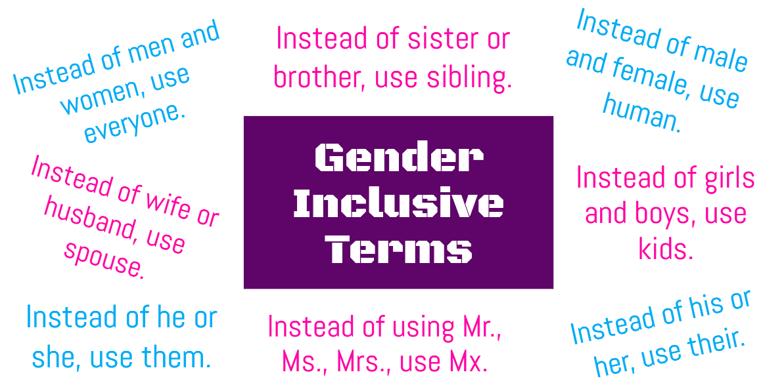

Go to your assignment to practice writing using gender-neutral language.

Other Persuasive Writing Techniques
Supporting file: 02_SUPPORTING_FILES_BY_UNIT/06 - Unit 5 Informative and Persuasive Texts/Other Persuasive Writing Techniques-d6d4529dcb.docx
Original package path: сontent/i8b0336bc-c478-4cdc-b8b6-58567174e99a/Persuasive Writing.docx

What is an Opinion Piece?
Opinions are strongly held beliefs. Although it's impossible to prove that an opinion is absolutely true or false, it is possible to support and recommend an opinion. That is what a writer does in an opinion piece.
An opinion piece is one kind of persuasive writing. It is an essay in which the writer expresses an opinion and then explains or defends it. Opinion pieces are found in most magazines, newspapers, blogs, podcasts, and posts on social media (Instagram, Facebook, Snapchat, X, etc.)

The Elements of an Opinion Piece
There are three elements that all opinion pieces must have.
- A Strong Statement of Opinion - this often appears in a single sentence close to the beginning of the piece.
- A Context - the writer must show why the opinion expressed is important to the writer or why it should be important to the reader. The context may be openly stated, or it may be implied throughout the selection.
- Support for the Opinion - a writer can use facts to support an opinion, but they can also use other kinds of support, such as general observations; predictions about future effects of an action; and appeals to the reader's interests.

How to Read an Opinion Piece
Beware! The writer of an opinion piece wants you to accept their point of view. To accomplish this goal, the writer might present clear arguments and support them with facts. However, the writer might use some facts while omitting others, or use a friendly tone just to win your trust.
You can resist this manipulation by being a critical reader. Reading critically does not mean looking only for weaknesses, tricks, and errors; it means asking questions and looking for your own answers. The questions a critical reader might have when reading an opinion piece like "Do We Need to Use Animals in Research" could be:
- Whose point of view is being expressed here? (sentence 1)
- Is this the only solution? (Sentence 3)
- Is this statement true? (Sentence 5)
- Who makes the choice? (Sentence 6)
- Is job placement the main purpose for education? (Sentence 8)
Every piece of writing expresses an opinion or an underlying bias, so it's important to read critically all the time. Ask yourself what the writer's point of view is and why. Compare it with your own and with other people's.

Opinion Essays
Some of the articles that appear in newspapers are opinion essays and not news reports. The opinions may be those of the newspaper's editorial board, or those of a columnist. Opinion essays are usually placed on the opinion-editorial pages of a newspaper.
On the following pages you will read several opinion essays.

"An Open Heart" by Judith Mackenzie - Personal Essay
"No Room for Compromise" by Ellen Goodman - Opinion Essay
"Attacked by a Mountain Grizzly" by Kathy Cook - Magazine Article

Your assignment will have comprehension questions that you must answer related to these readings.

An Open Heart
Supporting file: 02_SUPPORTING_FILES_BY_UNIT/06 - Unit 5 Informative and Persuasive Texts/An Open Heart-999d973bb0.pdf
Original package path: сontent/i67072ff0-a463-414d-98b5-53580919dc52/LA10-2 Unit 6 An Open Heart.pdf

No Room for Compromise
Supporting file: 02_SUPPORTING_FILES_BY_UNIT/06 - Unit 5 Informative and Persuasive Texts/No Room for Compromise-7abf6d987c.pdf
Original package path: сontent/if378173d-de07-418e-9509-8138e9fec79c/LA10-2 Unit 6 No Room for Compromise.pdf

Attacked by a Mt Grizzly
Supporting file: 02_SUPPORTING_FILES_BY_UNIT/06 - Unit 5 Informative and Persuasive Texts/Attacked by a Mt Grizzly-ee2e7cdfe0.pdf
Original package path: сontent/i12cb1a58-0c7b-48b9-92ac-5585c473a9b1/LA10-2 Unit 6 Attacked by a Mt Grizzly.pdf
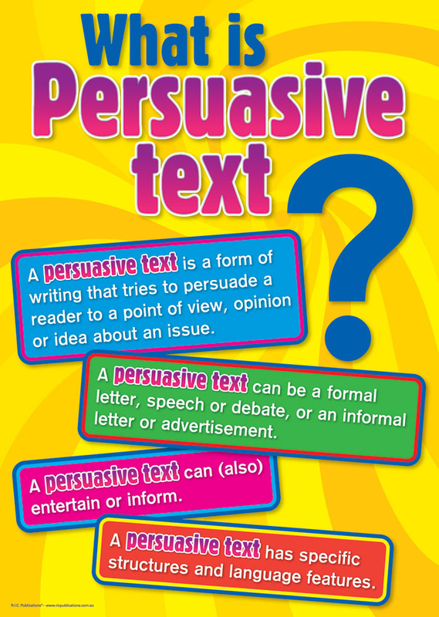

Persuasive Writing Basics
Supporting file: 02_SUPPORTING_FILES_BY_UNIT/06 - Unit 5 Informative and Persuasive Texts/Persuasive Writing Basics-92ebf57874.pdf
Original package path: сontent/i05e07a2b-8afd-4a91-b564-54cf4a4d68ea/Content/4.0 Persuasive Writing.pdf

Informative Letter Exemplar
Supporting file: 02_SUPPORTING_FILES_BY_UNIT/06 - Unit 5 Informative and Persuasive Texts/Informative Letter Exemplar-efbadc1eac.pdf
Original package path: сontent/i00b86381-5f08-43bb-a228-d1b702c3b76c/4.0 Letter Writing Exemplar.pdf

The Situation
The Prosper School Council is considering a proposal that would require all students to bring their own digital device (such as a notebook, tablet, or smartphone) to school in order to participate in digitally enhanced learning. Supporters of the Bring Your Own Device (BYOD) proposal believe that education is becoming more dependent on digital devices and that such technology is required by students in order to be competitive in academic environments. Those opposed believe that academic success is not dependent on the type of technology used and that such devices have the potential to adversely affect the educational environment.
In deciding whether to accept or reject the proposal, the Prosper School Council has invited concerned individuals to make their views known. You are Reggie Rivers, a recent graduate of Prosper High School. You have considered information and opinions from a variety of sources (see pages 14 and 15). After considering the advantages and disadvantages of the proposal, you have reached a decision. You now need to write a persuasive speech or letter that clearly develops your position

Writing a Persuasive Letter
Given the situation, you must write a letter to the Prosper School Board that will persuade them to either ACCEPT or REJECT the proposed school uniform policy.
When writing the letter, be sure to:
- consider your purpose and audience
- study the information below
- use an appropriate tone
Remember that you must clearly and directly choose to either accept or reject the proposed policy. You also want to use quotes as evidence to support your argument.

Source Information to Consider

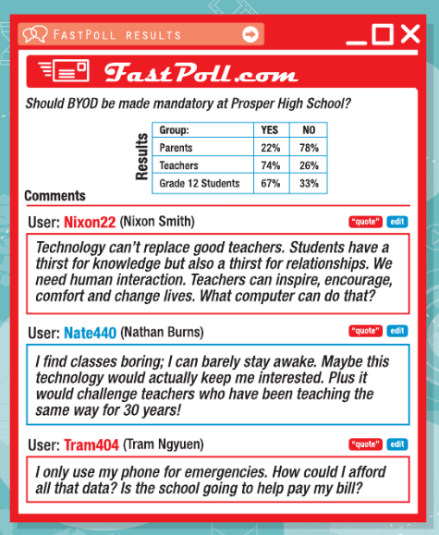
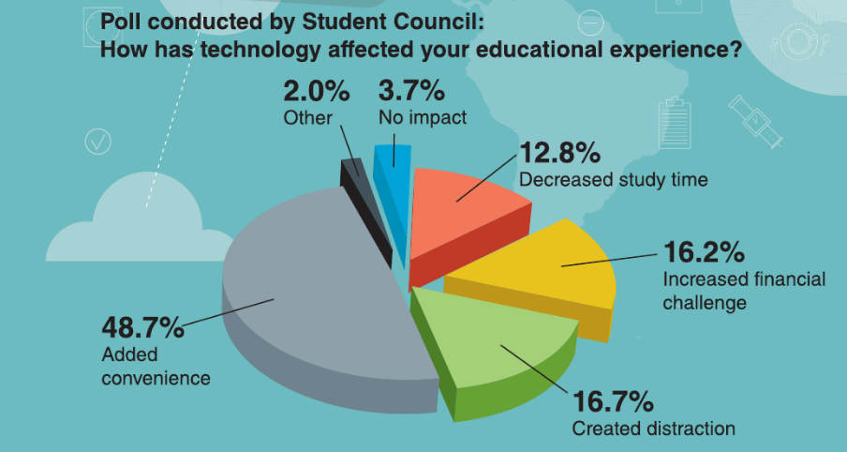





The Assignment:
Write a letter that will persuade the Prosper School Council to either ACCEPT or REJECT the Bring Your Own Device proposal.
In preparing your persuasive speech or letter, BE SURE TO
• study the information on the following pages
• consider your purpose and audience
• present a clear argument that explains the reasons behind your decision
• use an appropriate tone
Remember that you must clearly and directly choose either to accept or to reject the proposal.

The next page has an example of how you could write a persuasive letter in response to this assignment. Pay particular attention to the annotations in the boxes down the right side of the text.

Persuasive Letter Example
Supporting file: 02_SUPPORTING_FILES_BY_UNIT/06 - Unit 5 Informative and Persuasive Texts/Persuasive Letter Example-e210f4041d.pdf
Original package path: сontent/id6e01841-3701-469e-8e73-8ffd7b714990/ELA PERSUASIVE WRITING EXAMPLE.pdf

